**The war in Lebanon 1975 – 1990**

In April 1975, a bus transporting a group of Palestinians and passing through Ain el Remmaneh, was attacked by kataeb militia gunmen; the incident contributed to an atmosphere of high tension and was perceived as the spark that started a very tough period, similar in many ways to the one prevailing between 1969 and 1973.

On the internal level, tension was growing up: among conventional sectarian leaderships, between both leftist and rightist parties, as well as between the active union movement and a weakening political power. Finally, tension was growing up between a Palestinian resistance movement tempted to create a state among another, and an army torn by internal political divisions.

On the regional level, winds of change were blowing: Egypt was about to sign a peace agreement with Israel, as a first step of retiring from the conflict in the Middle East, while Arab disputes were deepening and Syria was witnessing a growing isolation.

On the international level, the cold war was at its peak, the USA attempting to compensate its defeat in Vietnam by way of making a victory in the Middle East, weakening the role of the Soviet Union, and excluding it from that strategic region in the world. As for the Soviet Union, it was preparing a counter attack.

**Document 1**

*Source:* Kamal Hamdan, **The Lebanese crisis, religious sects, social classes and national identity**, p.168-169, Al Farabi Edition and UNRISD, 1988.

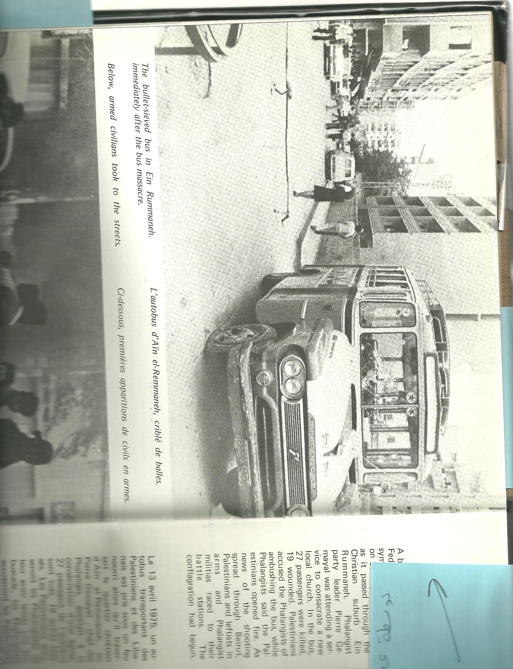

**The Ain el Remmaneh bus hit by bullets**

On April 13 1975, a bus carrying Palestinian Fedayeen was attacked as it passed in the Ain El Remmaneh suburb of Beirut. The bus carried 27 Palestinians who all died in the shooting. Fighting erupted on the demarcation line between Shiyyah and Ain el Remmaneh … and a war that will last 15 years started.

Document 2

Picture’s source: Days of Tragedy Lebanon 75-76, Joseph G Chami and Gerard Castoriades

Movements started with a long strike organized by high school students in March 1976, calling for the reduction of schooling fees, the annulment of the eliminatory mark as for foreign language, and the unification of school textbooks. In Tyre, The ISF opened fire on a student demonstration, killing the student Edward Ghanimeh. During June and the following weeks, the country witnessed a hectic student activity regarding the arab-israeli conflict, leading to the official closing of schools and universities and to the occupation of the AUB campus in Beirut and the expulsion of strikers . In April 1968, students and teachers of the Lebanese University started a strike that lasted 50 days. Teachers called for salaries increase and titularization, while students asked for a unified university campus, the increase of scholarships and the creation of university restaurants. The university administration disregarded the requests.

…In March 1972, The Union announced a strike to achieve demands. Private universities, AUB, USJ as well as the Arab University closed their doors in solidarity with the students of the public university. The Lebanese University went back to strike in the following year and ceased its movement, only after the police intervention and the expulsion of teachers. In 1972, Lebanon witnessed a general strike on the national level, including 16000 teachers from the public sector, calling for salaries increase, and the right for union organization, and retirement after 25 years of service. The strike lasted for 2 months, and was suspended following the decision of the ministry of education to stop paying the teachers’ salaries.

Student demonstrations became a daily event in Beirut streets and across the Lebanese cities. The last student demonstration took place prior to the war eruption (1975).

Document 3

Source - Fawaz Traboulsi,**Lebanon Modern History: from principality to Taef Agreement***,* p.300-305, Dar Riyad El Rayes, 2008.

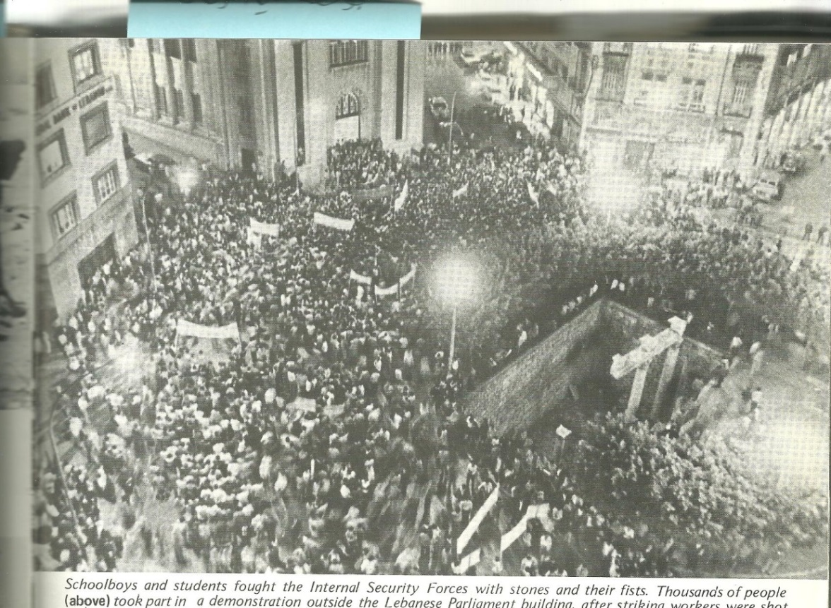

Document 4

Source - Joseph G Chami and Gerard Castoriadis (1980), Days of Tragedy Lebanon 75-76, Transaction Publishers

Thousands participated in a demonstration that took place outside the Lebanese parliament after striking workers were shot and arrested at the Ghandour factory for sweets. Two workers were killed and 14 were injured. Workers’ strike had started in November 1972.

According to a number of analysts, the crisis takes roots in an American-Israeli plan, aimed at imposing the peaceful settlement in the Middle East. This is done through the creation of a Palestinian state adjoining Israel, partially existing, however demilitarized on the Lebanese territory.

For this purpose, Lebanon and Syria would be divided into autonomous sectarian cantons, putting an end to an incurable and deeply rooted dilemma. Thus Israel lives within secure borders and the American domination prevails on the region.

In the light of this reality, analysts fully understand the American favorable position as for the escalating violence in the Arab region, namely in Lebanon. Indeed, since Israel categorically refuses the repatriation of Palestinian refugees to their homeland, and to cohabitate with them, it has convinced the American administration of the failure of coexistence between religions, quoting the Lebanese experience and its devastating aftermath.

… That was the beginning of the Lebanese crisis and its harsh events.

***Antoine Khoueiry "Lebanese events and incidents"*** 1975, vol 1, Dar Al Albjadiya, 1976.

Document 5

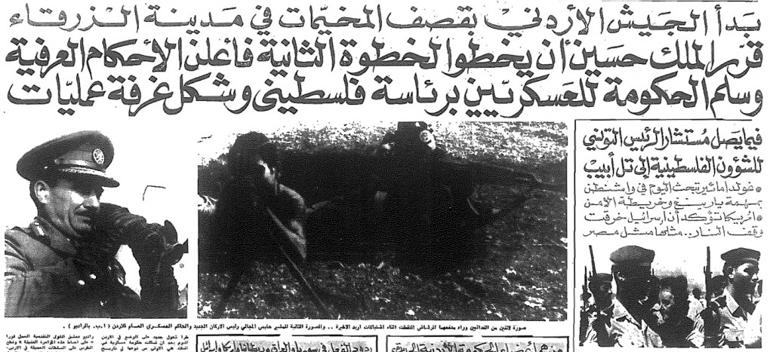

Following the “Black September” incidents in 1970, Palestinian factions were expelled from Jordan to Lebanon. As a result a war erupted in Lebanon where Yasser Arafat established the so-called “Fakhani Republic”, an area inside Beirut under full Palestinian control.

**Document 6 -** Source: https://uncarab408.web.unc.edu/

When passing in review the pre-war period, one could not but notice the prominent role of the Palestinian Resistance on the Lebanese scene.

… the Palestinian organization, Fateh, present in camps dotted about the cities suburbs, within poor life conditions, whether in Lebanon, Gaza, Jordan or Syria, has witnessed a significant expansion. In fact, it has developed from a small group created by a number of activists in Koweit in 1958, to a movement of national liberation, gaining in popularity. Following the initiation of the armed struggle in early 1965, camps residents started a self-organization process, some of them being trained secretly to the use of arms. Thus the camps became the birthplace of the armed conflict.

… The armed Palestinian presence in Lebanon started to expand following the year 1967, turning Lebanon to a “secure base” for the Palestinian resistance, on both political and armed levels, till 1975, and even till 1982. However, Lebanon was taking serious risks.

Samir Kassir, ***“The Lebanese War, from national discord to regional conflict”*** *1975-1982,* p. 61-62, Dar Alnahar, 2007.

Document 7

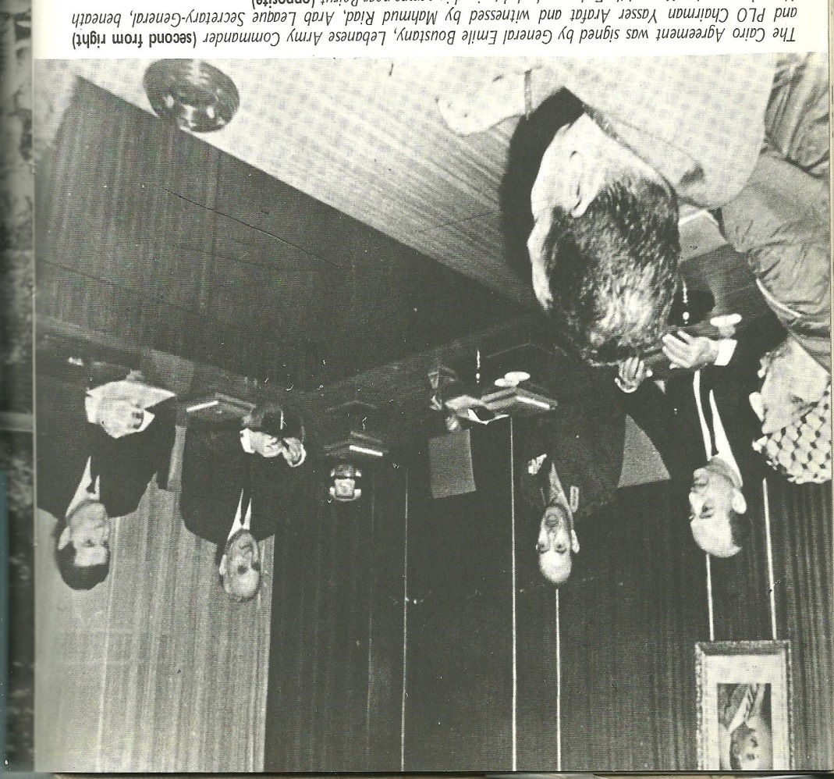

The Cairo agreement was concluded between Lebanese army commander General Emile Boustany and Yasser Arafat, head of the Palestinian Liberation organization (PLO), in the presence of the secretary of the Arab League, Mahmud Ryad.

The agreement recognized the political and military presence of the PLO on Lebanese territory, and tolerated the activities of Palestinian guerillas from Lebanon. It also protected Palestinians from attempts of disarmament. Some parties considered the agreement as violating the Lebanese sovereignty.

Document 8 - Picture’s source: Days of Tragedy Lebanon 75-76, Joseph G Chami and Gerard Castoriades

In 1943, a very important meeting was held between [Christian maronite]president Bechara el khoury and [Sunni prime minister] Riyad el Solh, where agreement was reached regarding the outlines of the “National Pact”. The pact considered by Muslims as an independence from the French mandate, was regarded by Christians as a detachment from Syria and Arabs.

Notwithstanding the above said, the sectarian shadow was threatening the first ministerial statement stipulating in its draft “Lebanon is an Arab country of a Christian face.” Following a long debate, the sentence was replaced by another: “Lebanon is an independent country with an Arab face”.

Hassan Hallak,***Lebanon modern history 1903-1953****,* Al Nahda al Arabiya edition. 3rd edition, 2010, p.227-228

Document 9

**Document 10**

***The Taef Agreement, reached with KSA mediation in September 30, 1989, in Taef, Saudi Arabia, ratified by 62 Lebanese deputies out of 73. It put an end to the Lebanese civil war.***

**National Reconciliation Accord- Taef Agreement**

2- Political Reforms

A - Chamber of Deputies

1. Until the Chamber of Deputies passes an election law free of sectarian restriction, the parliamentary seats shall be divided according to the following bases:
2. Equally between Christians and Muslims
3. Proportionately between the denominations of each sect.
4. Proportionately between the districts

These differences may find justification in the state structure, revolving around Maronites, and in spite of the valuable contribution of Maronite intellectuals in the Arab-syrian nationalist movement, the ideological space of the new state was characterized by a Lebanese strict uniqueness.

Indeed, the ideology revealed a number of flaws resulting from the affirmation of Lebanon historical rooting in the mountain, far off the remaining parts of *Bilad Al Sham*. Therefore, the oblivious reading of history found its legitimacy in the alleged survival and continuity of an entity that enjoys a relative sovereignty since the *Maani* Emirate, and in the tradition represented by a national church since the 8th century. Legitimacy was sought, with further absenteeism, to justify the expansion of the mountain to the city by adopting the legacy of Phoenician commercial cities. This ideological space ignored Arab leadership who called the Muslims to join Great Lebanon, irrespective of the cultural Arabism of the Maronites themselves.

The division deepened due to controversial relationship with the west, inherited by the society from the period prior to the state constitution. In spite of abandoning the French protection reinforced by the National Pact in 1943, a constructive image of France was being projected among the Maronite circle. As for Muslims, things were for sure different, since the double shock resulting from the collapse of the Ottoman Empire and the defeat in Maysaloun was deeply felt, and was inflamed by the need of confronting the west.

*Samir Kassir, Lebanese war, from national dissidence to regional conflict, 1975-1982, p.53-54, Al Nahar edition, 2007*.

**Document A**